**CHAPTER 1**

**INTRODUCTION**

Automatic generator is Java based software used to generate timetable automatically. Currently timetable is generated manually. It will help to manage all the period automatically and also it will manage the timetable when any one of the faculty is absent, late coming or early going.

By using this software users can apply for leave by providing leave required date, reason substitute and the hour or the period. Substitute can approve or reject request.

Time table is a very important part of the college management system. The timetable creation is a very old process in the college management system. Till now it is done manually. Each department assigns one faculty for this purpose and his job is to create timetable manually for each branch of every semester

As there are so many subject in each branch and one faculty will teaches two subjects in any two semester. There might be case when some collision will occur during assign the lectures manually.

In our college timetable management system we are trying to solve these problems and along with that we try to provide the user friendly and efficient way to generate the timetable automatically. Our project is a web based system in which faculty has to fill some form related to the college, branch, subjects and lab and then our system will generate the most possible timetable.

It is a comprehensive timetable management solution for college which help to overcome the challenges in manually setting the timetable. By using this software it will be very easy for faulty to get timetable from the system.

**CHAPTER 2**

**SYSTEM ANALYSIS**

System analysis is the process of gathering and interpreting facts and diagnosing problems and using this information to recommend improvements on the system. The system analysis is a problem solving activity that requires intensive communication between the users and the system developers. System analysis or study is an important phase of any system development process.

**2.1 EXISTING SYSTEM**

Time table scheduling was done manually with a single faculty or some group involved in task of scheduling it manually.

**Problems:**

* Timetable scheduling takes a lot of effort and time.
* Planning timetable is one of the most complex and error-prone applications.
* Maintenance and management is difficult.
* Heavy workload to the faculty who is associated with this.

**2.2 PROPOSED SYSTEM**

The Automatic timetable generator will help to manage all the periods automatically. There is no need for faculty to worry about their period details and maximum workload. By using this software, users can apply for leave by providing leave required date, reason, and also with substitute faculty. Substitute can approve or reject the request. Here the Super admin can view the entire faculty and they can select the admin from each department for generating the timetable. Proposed system will help to generate it automatically also helps to save time. It is a comprehensive time table management solution for colleges which helps to overcome the challenges in current system.

**Salient features of the system:**

* Automatic timetable manager is a java based software used to generate timetable automatically.
* Will help you to manage all periods automatically and also will be helpful for faculty who will get their timetable.
* It will also manage timetable when any teacher is absent late coming or early going.
* Proposed system will help to generate it automatically also helps save the time.
* There is no need for faculty to worry about their timetable.
* It is a comprehensive timetable management solutions for colleges which help to overcome the challenges in current system.

**2.3 FEASIBILITY STUDY**

A feasibility study was an evaluation of a proposal designed to determine the difficulty in carrying out a designated task. Generally, a feasibility study precedes technical development and project implementation.

The feasibility study is the important step in any software development process. This is because it makes analysis of different aspects like cost required for developing and executing the system, the time required for each phase of the system and so on. If these important factors are not analyzed then definitely it would have impact on the organization and the development and the system would be a total failure.

As estimate is made of whether the identified user needs may be satisfied using current software and hardware technologies. The study will decide if the proposed system will be cost effective from the business point of view and if it can be developed in the given existing budgetary constraints. The feasibility study should be relatively cheap and quick. The result should inform the decision of whether to go ahead with a more detailed analysis. By making analysis this way it would be possible to make a report of identified area of problem.

By making a detailed analysis in this area a detailed document or report is prepared in this phase which has details like project plan or schedule of the project, the cost estimated for developing and executing the system, target dates for each phase of delivery of system developed and so on. This phase is the base of software development process since further steps taken in software development life cycle would be based on the analysis made on this phase and so careful analysis has to be made in this phase.

Feasibility analysis involves 7 steps:

* Form a project and project a project leader.
* Prepare system flowcharts.
* Describe and identify characteristics of file search system.
* Determine and evaluate performance and cost effectiveness of the system.
* Weigh system performance and cost data.
* Select the best system.

**Advantages of making Feasibility study:**

* Helps in identifying the risk factors involved in developing and deploying the system.
* The feasibility study helps in planning for risk analysis.
* Feasibility study helps in making cost/benefit analysis which helps the organization and system to run efficiently.

The main objective of feasibility analysis is to test the technical, behavioral and economic feasibility of developing the computer based systems. This is done by investigating the existing system and generating the ideas about new system.

**2.3.1 Economic Feasibility**

To develop the proposed system, it needs no extra facilities and devices. All dependencies are satisfied from the open source projects. All tools used are free, open source and the program language is JSP and hence its development is economically.

**2.3.2 Technical Feasibility**

Proposed system is technically feasible because the proposed system requires only those hardware and software tools that are available in the system. It requires the installation of JSP and MYSQL which can be done for free. Moreover expandability will be maintained in the new system. New modules can be added later on the application, if required in the future. Additionally the application will have user friendly forms and screens.

**2.3.3 Behavioral Feasibility**

Behavioral feasibility determines how much effort will go in the proposed information system, and in educating and training the users on the new system. Since the user interface is very simple and easily understandable, no training is required for using this software.

**CHAPTER 3**

**SYSTEM SPECIFICATION**

**3.1 SOFTWARE SPECIFICATION**

One of the most difficult tasks is selecting the software. Once the system requirement is found out then we have to determine whether a particular software package fits for those system requirements. This section summarizes the application requirements:

|  |  |
| --- | --- |
| Operating System | : LINUX / WINDOWS 7 or Above |
| Technology  Web Technologies  Web Server | : JSP / SERVLET  : XHtml , Java Script, CSS  : Glassfish |
| IDE  Compiler  Database  Web Browser | : NetBeans 7.3.1  : JDK  : MySQL  : Mozilla Firefox / Google Chrome |
|  |  |

**3.1.1 INTRODUCTION TO NETBEANS**

NetBeans is an Integrated Development Environment (IDE) for java. NetBeans allows application to be developed from a set of modular software component called modules. NetBeans runs on Linux, Microsoft Windows, macOs, Solaris. It provides first class comprehensive support for the newest Java technologies and latest Java enhancement before other IDEs. With it’s constantly improving Java Editors, many rich features and an extensive range of tools, templates and samples. NetBeans IDE sets the standard for developing with cutting edge technologies out of the box.

**3.1.2 INTRODUCTION TO MYSQL** MySQL is an open-source relational database management system. MySQL was owned and sponsored by a single [for-profit](https://en.wikipedia.org/wiki/Business) firm, the [Swedish](https://en.wikipedia.org/wiki/Sweden) company [MySQL AB](https://en.wikipedia.org/wiki/MySQL_AB), now owned by [Oracle Corporation](https://en.wikipedia.org/wiki/Oracle_Corporation). Web Services are used for connecting android application to MySQL. **3.2 HARDWARE SPECIFICATION**

The Selection of hardware is very important in the existence and proper working of any of the software. When selecting hardware, the size and capacity requirements are also important.

|  |  |
| --- | --- |
| Hardware | : Pentium |
| Speed | : 2 Ghz |
| RAM | : 2 GB |
| Hard Disk | : 80 GB |

**3.3 LANGUAGE SPECIFICATION**

**3.4.1 JAVA**

Java was convinced by James Gosling, Patrick Naughton, ChrisWarth, Ed Frank and Mike Sheridan at SUN Micro Systems Incorporation in 1991. It took 18 Months to develop the first working version. This language was initially called “OAK”, but was renamed “JAVA” in 1995. Before the initial implementation of OAK in 1992 and the public announcement of Java in 1995, many more contributed to the design and evolution of the language.

**Overview of Java**

An Object Oriented Programming Language (OOPS) developed at Sun Microsystems. A Virtual Machine Run Time Environment that can be embedded in web browser (IE, NN). Java is powerful but lean object-oriented programming language. It has generated a lot of excitement because it makes it possible to program for Internet. By creating applets, programs can be embedded in webpage. The context of an applet is limited only by one’s imagination. For example, an applet can be an animation with sound, an interactive game or a ticket tape with constantly updated Stock prices. Applets can be serious application like word processor or spreadsheet. But Java is more than a programming language for writing applets. It is being used more and more for writing standalone applications as well. It id becoming so popular that many people believe it will become standard language for both general purpose and Internet programming. There are many buzzwords associated with Java, but because of its spectacular growth in popularity, a new buzzword has appeared ubiquitous. Indeed, all indication is that it will soon be everywhere. Java builds on the strength of C++. It has taken the best features of C++ and discarded the more problematic and error prone parts. To this lean core, it has added garbage collection (automatic memory management), multithreading (the capacity for one program to do more than one thing at a time), security capabilities. The result is simple, elegant, powerful and easy to use.

**Object Oriented Features**

The Java programming language is object oriented, which makes program design focus on what the user is dealing with rather than on how the user is going to do something. This makes it more useful for programming in sophisticated projects because one can break the things down into understandable components. A big benefit is that these components can then be reused.

Object oriented languages use the paradigm of classes. In simplest term, a class includes both data and the functions to operate on the data. User can create an instance of a class, also called an object, which will have all the data members and functionality of its class. Because of this, user can think of a class as being like template, with each object being a specific instance of a particular type of class. The class paradigm allows one to encapsulate data so that specific data values are those using the data cannot see function implementation. Encapsulation makes it possible to make changes in code without breaking other programs that use that code. If for example the implementation of a function is changed, and it does not affect his/her program, except hopefully to improve it. Java includes inheritance, or the ability to derive new classes from existing classes. The derived class, also called a subclass, inherits all the data and the functions of the existing class, referred to as the parent class. A subclass can add new members to those inherited from the parent class. As far as methods are concerned, the subclass can reuse inherited methods as it is, changed them, and/or add its own new methods.

**CHAPTER 4**

**SYSTEM DESIGN**

System design is the process of identifying the main component of the system without going to its interior details. Each component is considered to black box, meaning that for a given input, a specific output is produced, but the details of the input is being processed is not known. Each component in the phase is called a module. This phase also emphasizes the interactions between the modules. In this phase the design selected in the study phase is accomplished.

The main activities performed during this phase include the following:

* The allocation of functions between the programs.
* Selection of equipment and manual operations.
* The design of the database used.
* Specification of requirements for input, processing and output.
* Definition of system and computer program test requirement.

**4.1 DATA FLOW DIAGRAM**

A DFD is a structured analysis and design tool that can be used for flow charting. A DFD is a network that describes flow of data and process the change or transforms data throughout a system. This is constructed using a set of symbols.

- -External Entity

- Data Flow

- Process

- Data Storage

- Database

The DFD at the simplest level is referred to as the ‘Context Analysis Diagram’. These are expanded by level, each explaining its process in detail. Processes are numbered are for easy identification and are normally labeled in block letters. Each Data Flow is labeled for easy understanding.

**LEVEL0:**

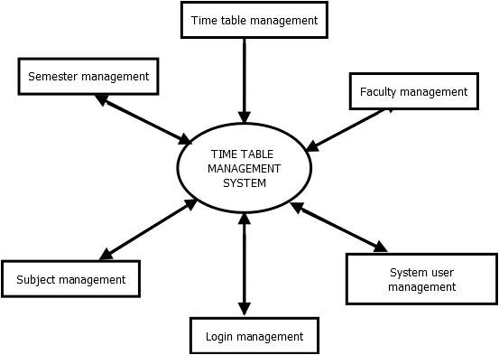

The above figure represents the overall system. It contains six modules-Time table management, system user management, login management, subject management, semester management, and faculty management.

**LEVEL1:**

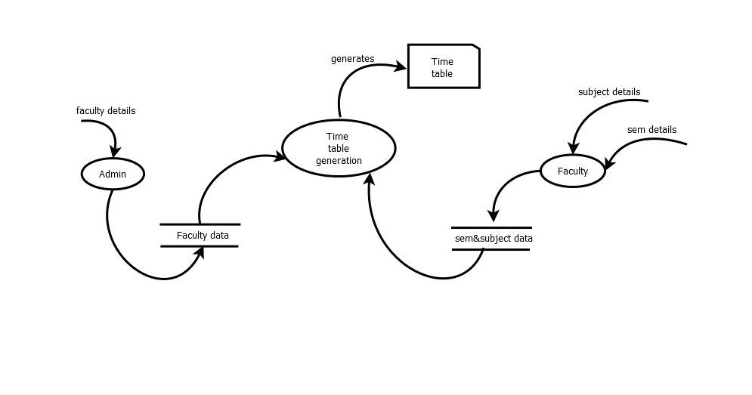 Admin store the faculty details and faculty will store their subject and semester details into database. From combining these data, time table will generate

**LEVEL 2: ADMIN**

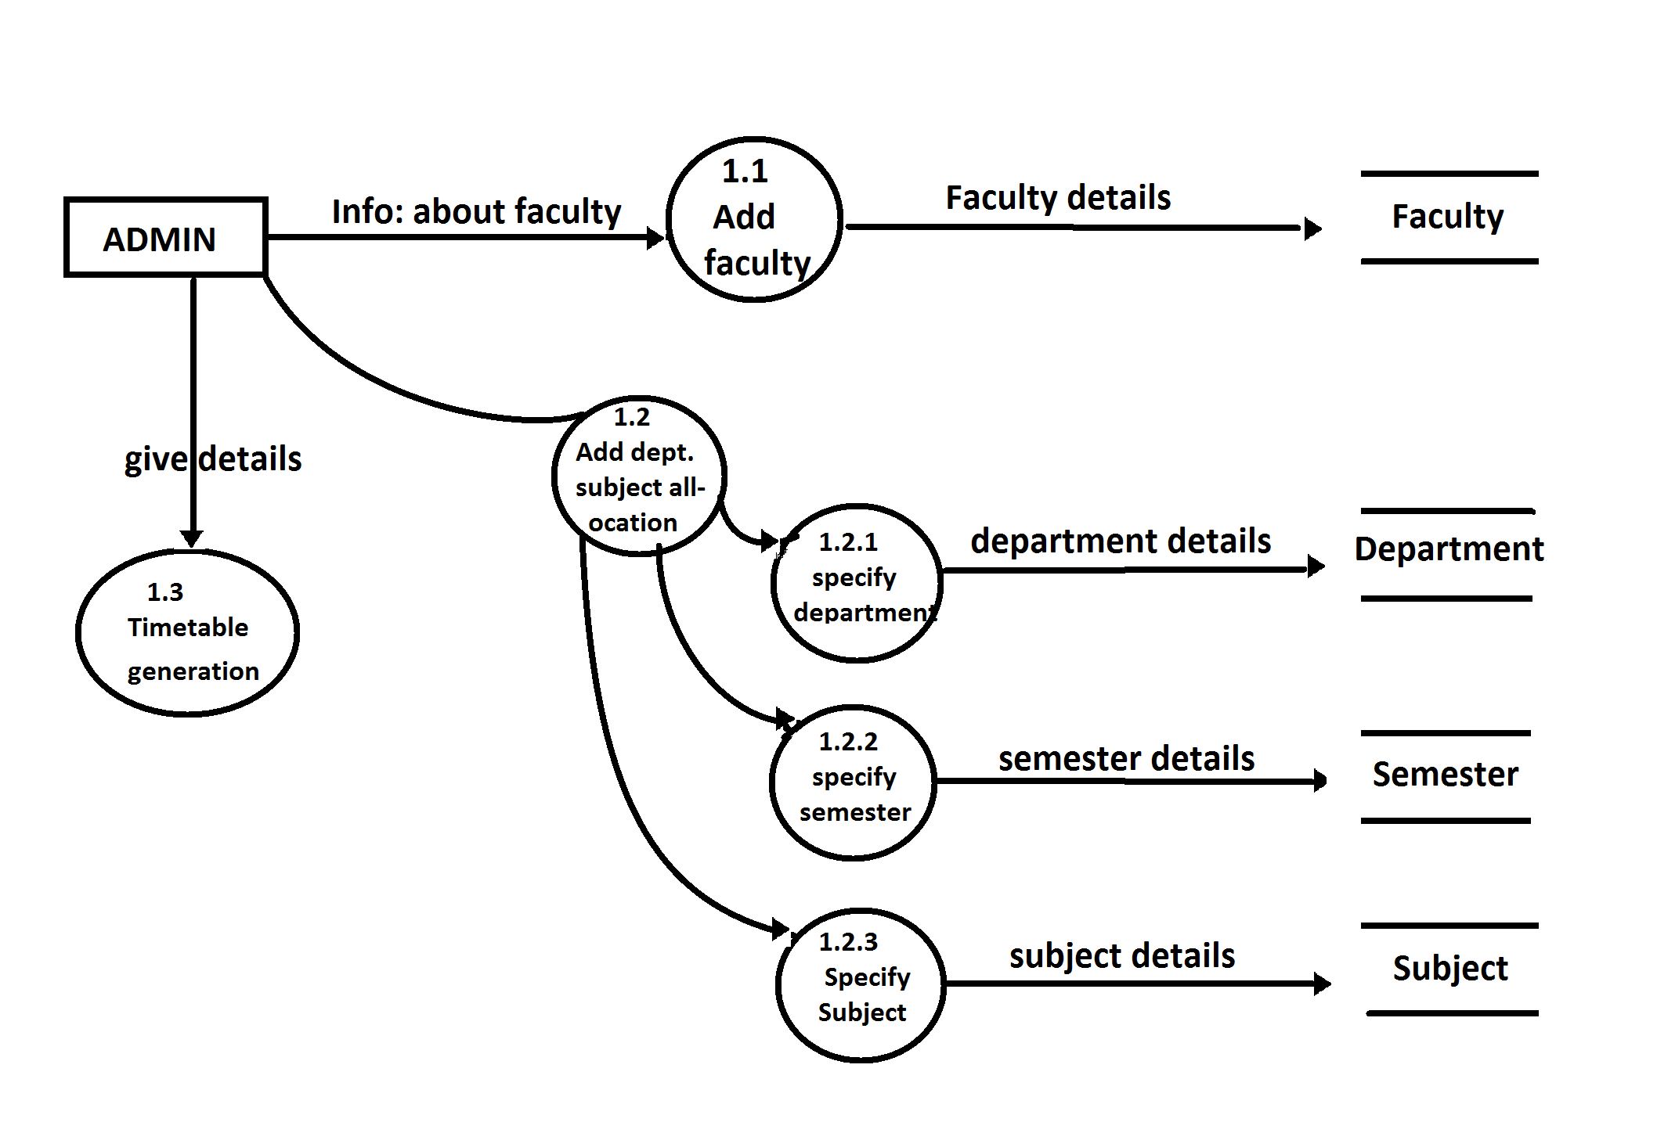

Admin will collect the faculty details and store into the database and allocate subjects for each department with department, semester, and subject details. Admin will generate the time table.

**LEVEL 2: FACULTY**

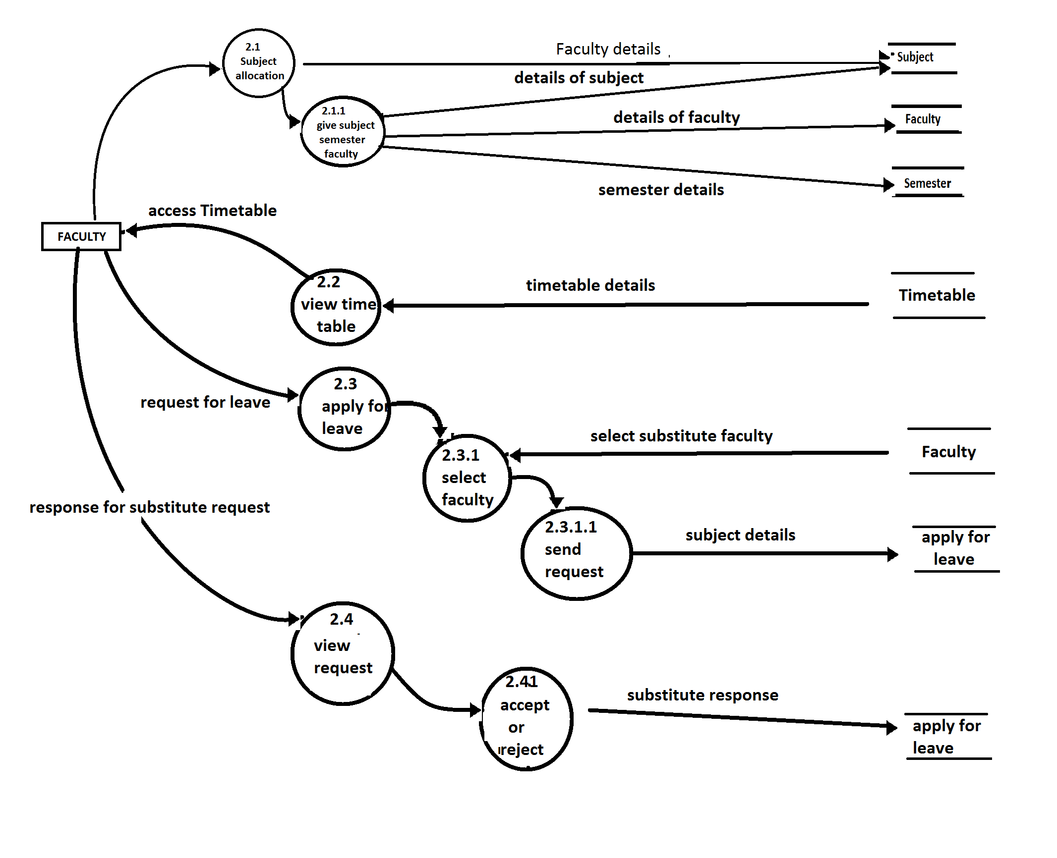

Faculty allocate their subject and details. They can access the time table and request for leave and respond to their substitute requests.

**4.3 DATABASE DESIGN**

Database design is an integrated approach to file design. The general theme is to handle information as an integrated whole, with a minimum of redundancy and improved performance. Software languages are used to manipulate, describe and manage data. Regardless of the type of data structure used, the objectives of the databases are:

* Accuracy and Integrity.
* Successful recovery from failure.
* Privacy and security of data.
* Good overall performance.

In a database environment common data are available and used by several users. Instead of each program managing its own data, authorized users share data across applications with the database software managing the data as an entity.

The objectives of the database are:

**1.Controlled Redundancy :**Data is stored only once avoiding the conflicting information and thus improving the performance.  
**2. Ease of learning and use:** With the use of proposed system, databases can be modified without interfacing with the established ways of using data.

**3. Data Independence :**The database should be able to improve its performance without rewriting of applications, programs for changing hardware and storage procedures.

**4. More Information at low cost:** Programming and software enhancements should be kept simple and easy to update.

**5. Accuracy and Integrity:** Data quality and content remain constant, Integrity controls the data inaccuracies.

**6. Recovery from failure:** The system must recover quickly after it is down with no loss of transactions.

**7. Privacy and Security:** Security measures must be taken to prevent unauthorized access and destruction from natural calamities.

**8. Performance:** It depends on the nature of the user database dial.

**4.3 Structure of Tables**

Tables used in this application are:

* **DEPARTMENT:** To store details of departments.
* **FACULTY:** To store the details of Faculty.
* **DEP_SUB_ALLOCATION:** To store the details of Subjects of corresponding departments.
* **FAC_SUB_ALLOCATION:** To store the details of subjects of each faculty.
* **SUBJECT:** To store the details of Subjects.
* **APPLY_4_LEAVE:** To store leave details.
* **LOGIN:** To store the login details.
* **TT:** To Store the details of timetable.

**LOGIN TABLE**

|  |  |  |
| --- | --- | --- |
| **Attribute** | **Datatype** | **Constraints** |
| USERNAME | VARCHAR(5O) | Primary key |
| PASSWORD | VARCHAR(50) | Not NULL |
| TYPE | INT(11) | Not NULL |

**DEPARTMENT TABLE**

|  |  |  |
| --- | --- | --- |
| **Attribute** | **Data type** | **Constraints** |
| DEPARTMENTID | VARCHAR(100) | Primary key |
| DEPARTMENTNAME | VARCHAR(150) | Not NULL |

**SUBJECT TABLE**

|  |  |  |
| --- | --- | --- |
| **Attribute** | **Data type** | **Constraints** |
| SUBCODE | VARCHAR(50) | Primary key |
| SUBJECT | VARCHAR(100) | Not NULL |

**FACULTY TABLE**

|  |  |  |
| --- | --- | --- |
| **Attribute** | **Data type** | **Constraints** |
| FACID | VARCHAR(25) | Primary key |
| FACNAME | VARCHAR(50) | Not NULL |
| DOB | DATE | Not NULL |
| EMAIL | VARCHAR(25) | Not NULL |
| DEPARTMENTID | VARCHAR(100) | MUL |

**APPLY_4_LEAVE TABLE**

|  |  |  |
| --- | --- | --- |
| **Attribute** | **Data type** | **Constraints** |
| ID | VARCHAR(25) | Primary key |
| DATE | DATE | Not NULL |
| REASON | VARCHAR(1500) | Not NULL |
| REQUESTEDBY | VARCHAR(1500) | Not NULL |
| SUBSTITUTE | VARCHAR(1500) | Not NULL |
| PERIOD | INT(11) | Not NULL |
| APPROVED | INT(11) | Not NULL |

**DEPT_SUB_ALLOCATION TABLE**

|  |  |  |
| --- | --- | --- |
| **Attribute** | **Data type** | **Constraints** |
| ID | INT(11) | PK |
| DEPARTMENTID | VARCHAR(50) | FOREIGN KEY |
| SUBCODE | VARCHAR(50) | Not NULL |
| SEMNO | VARCHAR(20) | Not NULL |

**FACULTY_SUB_ALLOCATION TABLE**

|  |  |  |
| --- | --- | --- |
| **Attribute** | **Data type** | **Constraints** |
| ID | INT(11) | Primary key |
| FACID | VARCHAR(25) | Not NULL |
| SUBCODE | VARCHAR(50) | Not NULL |

**TT TABLE**

|  |  |  |
| --- | --- | --- |
| **Attribute** | **Data type** | **Constraints** |
| BATCHNO | VARCHAR(50) | Not NULL |
| ROWID | VARCHAR(50) | Not NULL |
| COLID | VARCHAR(50) | Not NULL |
| CODE | VARCHAR(50) | Not NULL |
| DEPID | VARCHAR(50) | Not NULL |

**CHAPTER 5**

**IMPLEMENTATION**

Implementation Phase is the phase which involves the process of converting new system design into an operational one. It is the key stage in achieving a new successful system.

Implementation stage should be planned and controlled carefully. The implementation stage has its own right. It involves careful planning, investigation of the current system and its constraints on the implementation, design methods to achieve the change over procedures and evaluation of change over methods.

Time table generator can be implemented as web application. Java is used for the developing the front end of the application. The Back end of the system is coded using MySQL. It is an open source relational database management system. We use web services to connect application with MySQL.

Here we have a super admin, he or she can add admin for each department, that is who has the duty for creating timetable. The super admin can also view all the facilities.

Admin can add facilities, subjects and also delete them. Admin allocate these subjects to their department then it generate timetable. If the time table generated successfully then all the facilities can view the time table.

The system contains mainly 2 users. Each users have their own functionalities. First, we prepared the login Page. Primarily admin will be from the development team. Admin needs to register himself. Once admin registers himself, he can login. Then he will add the faculties for every department .Admin will allocate subjects for each department. Faculty can login with their default password, they can change it. After login they can add the subjects, apply four leave, can view the request from substitute and they can view the timetable.

We use a Genetic Algorithm to solve the timetable problems. It is a search based optimization technique based on the principles of genetic and natural selection.

So using this application in educationalinstitutions, they can generate time table for any number of courses and multiple semesters.

**5.1 Input**

Admin first logs in using username and password. Admin registers faculties and allocate subjects for departments. Admin can also generate timetable. Faculty logs in using their id and password and add their subject. Both the users can apply for the leave and they can also view the leave request. This request that has been send from other facilities can be accepted or deleted.

**5.2 Database Storage**

After the faculty login, the faculty details such as username and password get inserted to database. Faculty can view the faculty details, subject details, their substitute requests and time table. It is made possible because these data while entering will be stored into corresponding database and from this tables the data’s are fetched. Admin also has the ability to delete and add the faculties and subjects.

**5.3 Output**

After generating the time table by admin using the details from the database, user can view the time table of different semester of different departments.

**5.4 Coding**

<!--Apply For Leave-->

/*

* To change this template, choose Tools | Templates

* and open the template in the editor.

*/

package com.beans;

import java.util.List;

import javax.faces.bean.ManagedBean;

import javax.faces.bean.RequestScoped;

import javax.faces.context.FacesContext;

import javax.servlet.http.HttpSession;

/**

*

* @author **

*/

@ManagedBean

@RequestScoped

public class ApplyForLeaveBean {

DBConnection db = null;

private int id;

/**

* Get the value of id

*

* @return the value of id

*/

public int getId() {

return id;

}

/**

* Set the value of id

*

* @param id new value of id

*/

public void setId(int id) {

this.id = id;

}

private List<FacultyBean> lstfaculty;

private String singlesubstitute;

/**

* Get the value of singlesubstitute

*

* @return the value of singlesubstitute

*/

public String getSinglesubstitute() {

return singlesubstitute;

}

/**

* Set the value of singlesubstitute

*

* @param singlesubstitute new value of singlesubstitute

*/

public void setSinglesubstitute(String singlesubstitute) {

this.singlesubstitute = singlesubstitute;

}

/**

* Get the value of lstfaculty

*

* @return the value of lstfaculty

*/

public List<FacultyBean> getLstfaculty() {

lstfaculty = db.getfaculty("select * from faculty");

return lstfaculty;

}

/**

* Set the value of lstfaculty

*

* @param lstfaculty new value of lstfaculty

*/

public void setLstfaculty(List<FacultyBean> lstfaculty) {

this.lstfaculty = lstfaculty;

}

private String Date;

/**

* Get the value of Date

*

* @return the value of Date

*/

public String getDate() {

return Date;

}

/**

* Set the value of Date

*

* @param Date new value of Date

*/

public void setDate(String Date) {

this.Date = Date;

}

private String Reason;

public String getReason() {

return Reason;

}

/**

* Set the value of Reason

*

* @param Reason new value of Reason

*/

public void setReason(String Reason) {

this.Reason = Reason;

}

private String[] substitute;

/**

* Get the value of substitute

*

* @return the value of substitute

*/

public String[] getSubstitute() {

return substitute;

}

/**

* Set the value of substitute

*

* @param substitute new value of substitute

*/

public void setSubstitute(String[] substitute) {

this.substitute = substitute;

}

private int Period;

/**

* Get the value of Period

*

* @return the value of Period

*/

public int getPeriod() {

return Period;

}

/**

* Set the value of Period

*

* @param Period new value of Period

*/

public void setPeriod(int Period) {

this.Period = Period;

}

private String from;

/**

* Get the value of from

*

* @return the value of from

*/

public String getFrom() {

return from;

}

/**

* Set the value of from

*

* @param from new value of from

*/

public void setFrom(String from) {

this.from = from;

}

public ApplyForLeaveBean() {

db = new DBConnection();

}

public String doSave() {

String Date = getDate();

String Reason = getReason();

String Substitute[] = getSubstitute();

int Period = getPeriod();

FacesContext facesContext = FacesContext.getCurrentInstance();

HttpSession session = (HttpSession) facesContext.getExternalContext().getSession(false);

String from = session.getAttribute("username").toString();//, username);

String sql = "INSERT INTO apply4leave(date,reason,requestedby,substitute,period,approved) VALUES";

System.out.println(Substitute.length);

for (int i = 0; i < Substitute.length; i++) {

System.out.println(Substitute[i]);

sql = sql + "('" + Date + "','" + Reason + "','" + from + "','" + Substitute[i] + "'," + Period + ",0),";

}

sql = sql.substring(0, sql.lastIndexOf(","));

System.out.println("sql =" + sql);

int s = db.executeSQL(sql);

if (s > 0) {

System.out.println("Inserted");

} else {

System.out.println("Failed..");

}

System.out.println("Date =" + Date + " Reason=" + Reason + "Substitute=" + Substitute + "Period=" + Period);

return "ViewLeave.xhtml";

}

}

**CHAPTER 6**

**TESTING**

Testing is the process of executing the program with the intent of finding errors. Testing cannot show the absence of defects, it can only show that software errors are present. System testing is vital for the success of any software system. In this phase, several tests and validations will be carried out on modules to check for their functionality. Testing and debugging is very critical in system development. The quality of the system is confirmed by the thoroughness of its system development life cycle and hence influences overall productivity during the system development. In this phase the errors in the program or module are localized and modifications are done to eliminate them. Some of the methods of system testing are given below:

**6.1 UNIT TESTING**

In unit testing different modules are tested against the specifications produced during design phase for the modules in the project and the goal is to test the internal logic of the modules.

In order to perform the unit testing, the best approach we adopted in this project is functional testing in which input are given to the system for which the expected results are known, boundary values and special values. The admin module has be tested for its proper functioning, since all services are provide and data is stored and controlled by this module. Unit testing focuses verification error on the smallest unit of software design in the module.

**6.2 INTEGRATION TESTING**

Integration testing is a systematic technique for constructing the program structure while at the same time conducting tests to uncover errors associated with interfacing.

Unit tested built that has been dictated by the design. Incremental integration has adopted here. The entire software was developed and tested in small segments; where errors were easy to locate and rectify. Each database or table manipulation operation was written as single programs and separately tested and combined to form a single program. After integration, the single program was tested again with numerous test data to check for its functionality. The integration can be performed in two ways –Top down integration and bottom up integration. Here bottom up integration is performed. The subject module, faulty module, department module integrated together for proper functioning of the whole system.

**Alpha Testing:**

A series of acceptance tests were conducted to the time table module to validate requirements. The end user conducted it.

**Beta Testing:**

It is to be conducted by the end –user without the presence of the developer. It can be conducted over a period of weeks or month. Since it is a long time consuming activity, its result is out scope of this project report. But its result will help to enhance the product at a later time.

**6.3 SYSTEM TESTING**

System testing tests a completely integrated system to verify that it meets its requirements. System testing is a level of software designing where complete and integrated software is tested.

**CHAPTER 7**

**SYSTEM MAINTENANCE**

System maintenance is the set of activities that are performed to modify the System after it is delivered to the customer to correct faults or to improve performance. It is an important thing in the field of software engineering. By system maintenance, the different requirements and new problems of customers can be maintained effectively.

Maintenance can be categorized into three but here we use 2 categorization of maintenance;

**1. Adaptive:** dealing with changes and adapting in the software environment

**2. Corrective**: dealing with errors found and fixing it.

Requirements are the main source of maintenance and changes is an intrinsic property of software. Thus the system maintenance has much importance.

**CHAPTER 8**

**CONCLUSION**

It is a difficult task to allocate subjects manually .So proposed system helps to overcome this difficulty. It can generate timetable automatically. There is no worry for time clashes and overlapping.

* Helpful for creating timetable in educational institutions.
* Equal distribution of work among teacher
* Helps in arranging proxy periods
* No time clashes and overlapping

**CHAPTER 9**

**REFERENCES**

[1] Elmasri & Navathe , “*Fundamentals of Database System*”, Pearson Education, Fourth edition.

[2] Rajib Mall,”*Fundamentals of Software Engineering*”, PHI Second edition.

[3] Dipesh Mittal, Hiral Doshi, Mohammed Sunasra, Renuka Nagpure, ‘International Journal of Advanced Research in Computer and Communication Engineering (IJARCCE), 2015.

**APPENDIX-I**

**SCREENSHOTS**

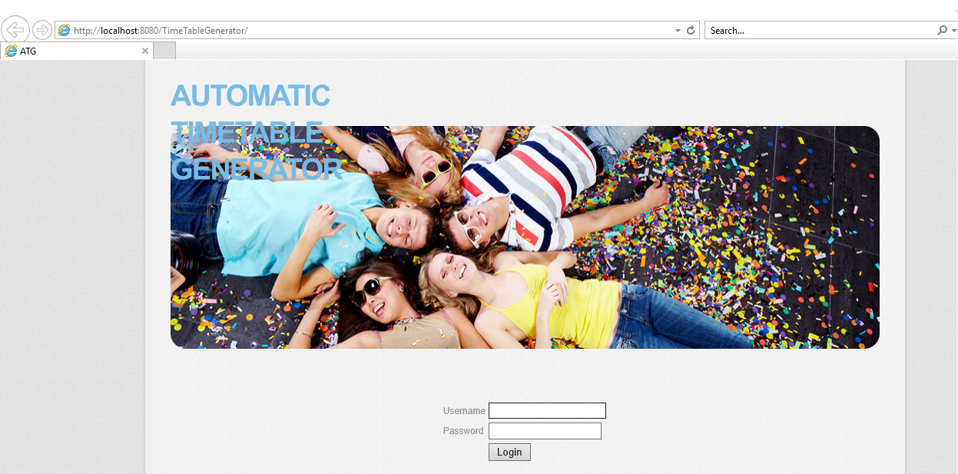

**1. Login page**

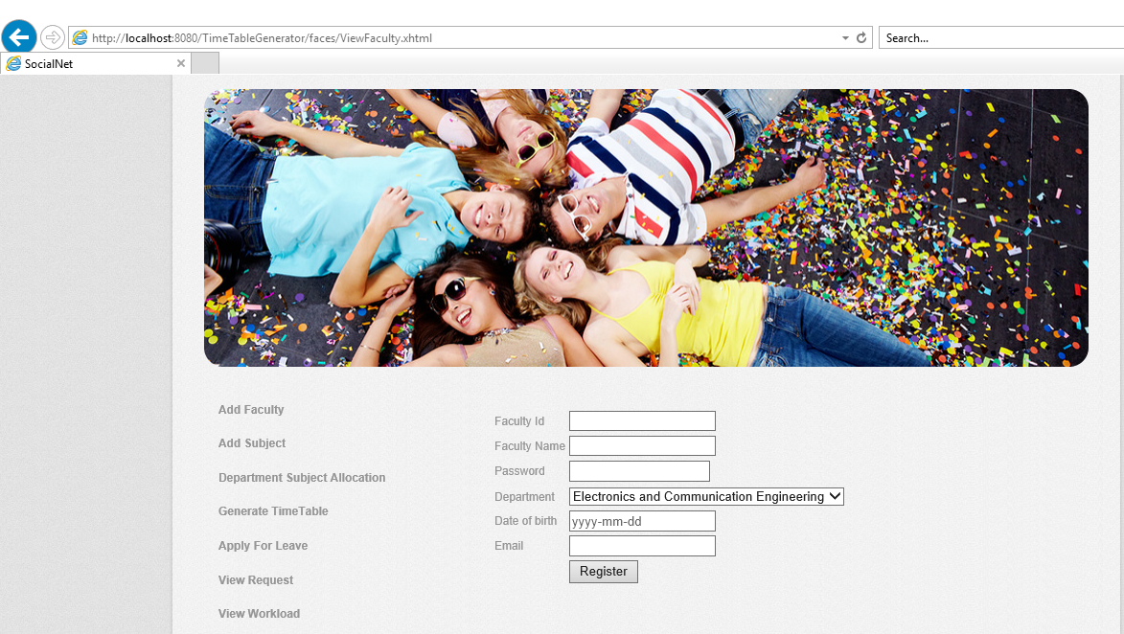

**2. Add faculty**

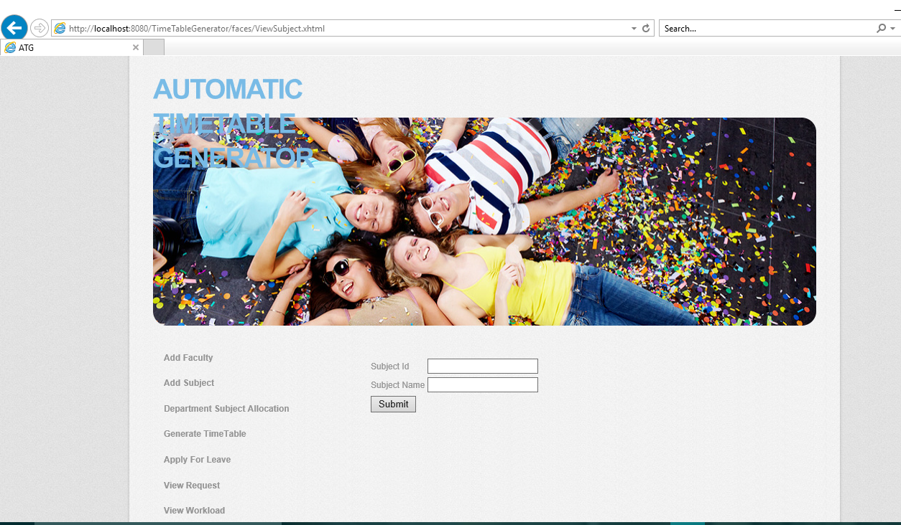

**3. Add subject**

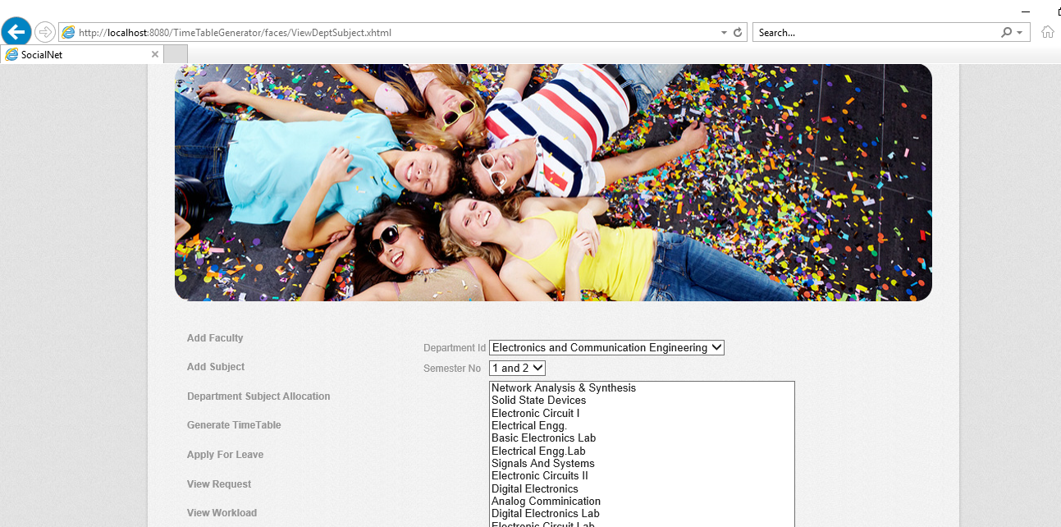

**4. Department subject allocation**

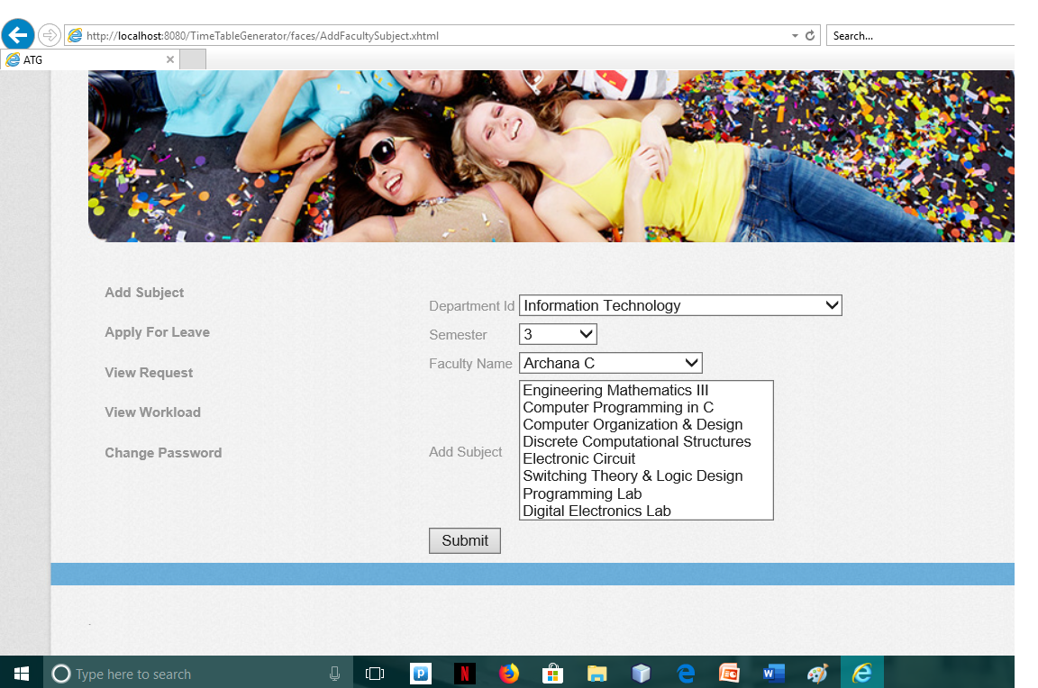

**5. Faculty subject allocation**

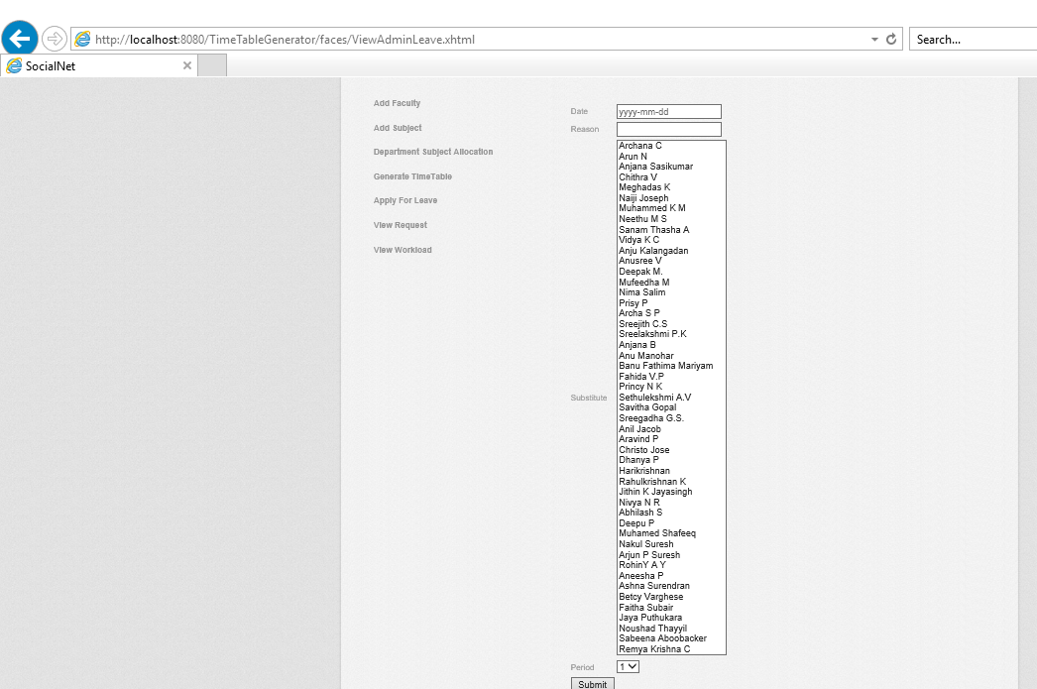

**6. Apply for leave**

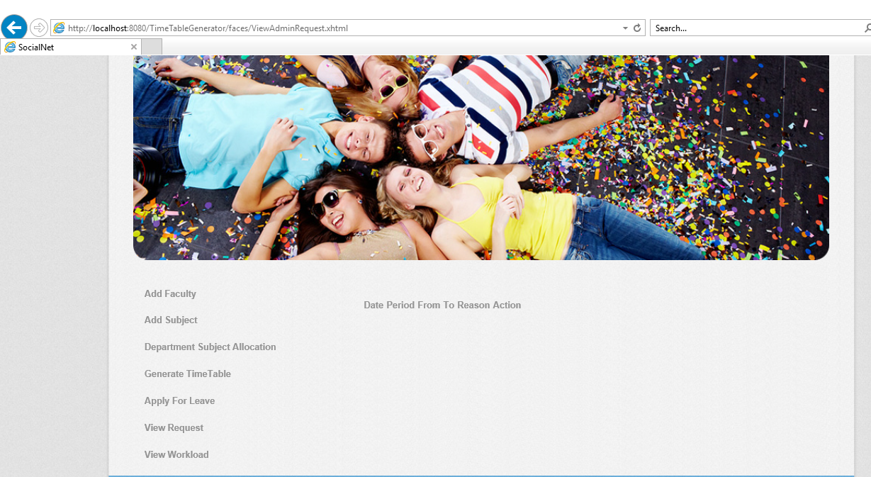

**7. View request**

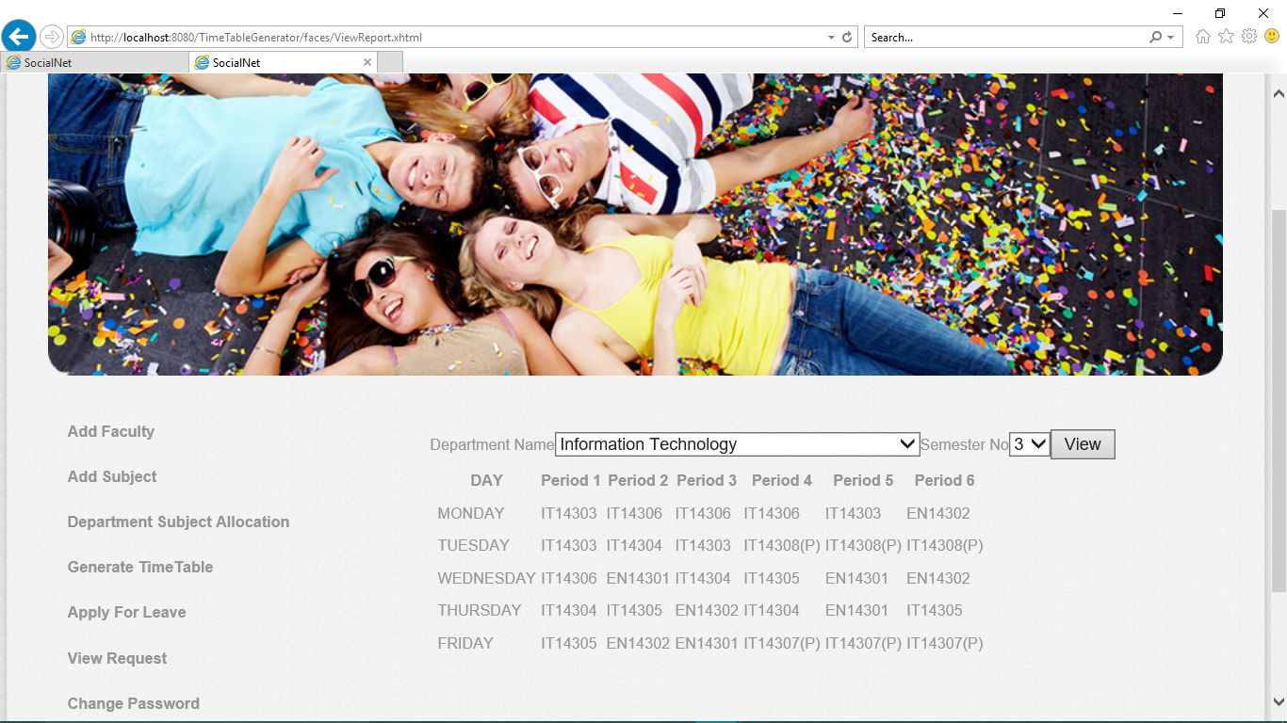

**8. View Timetable**